Selecting the **volume** tab in the EC2 dashboard

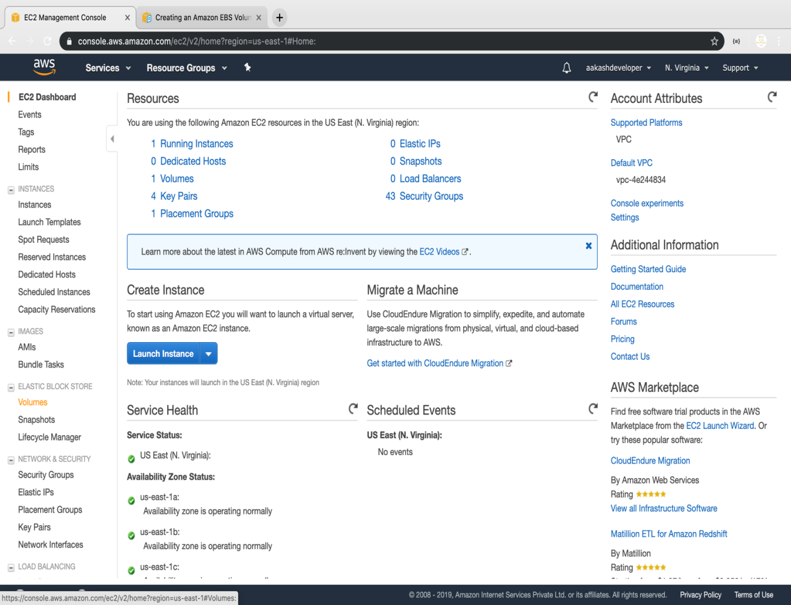

Creating a new volume by clicking on **Create**

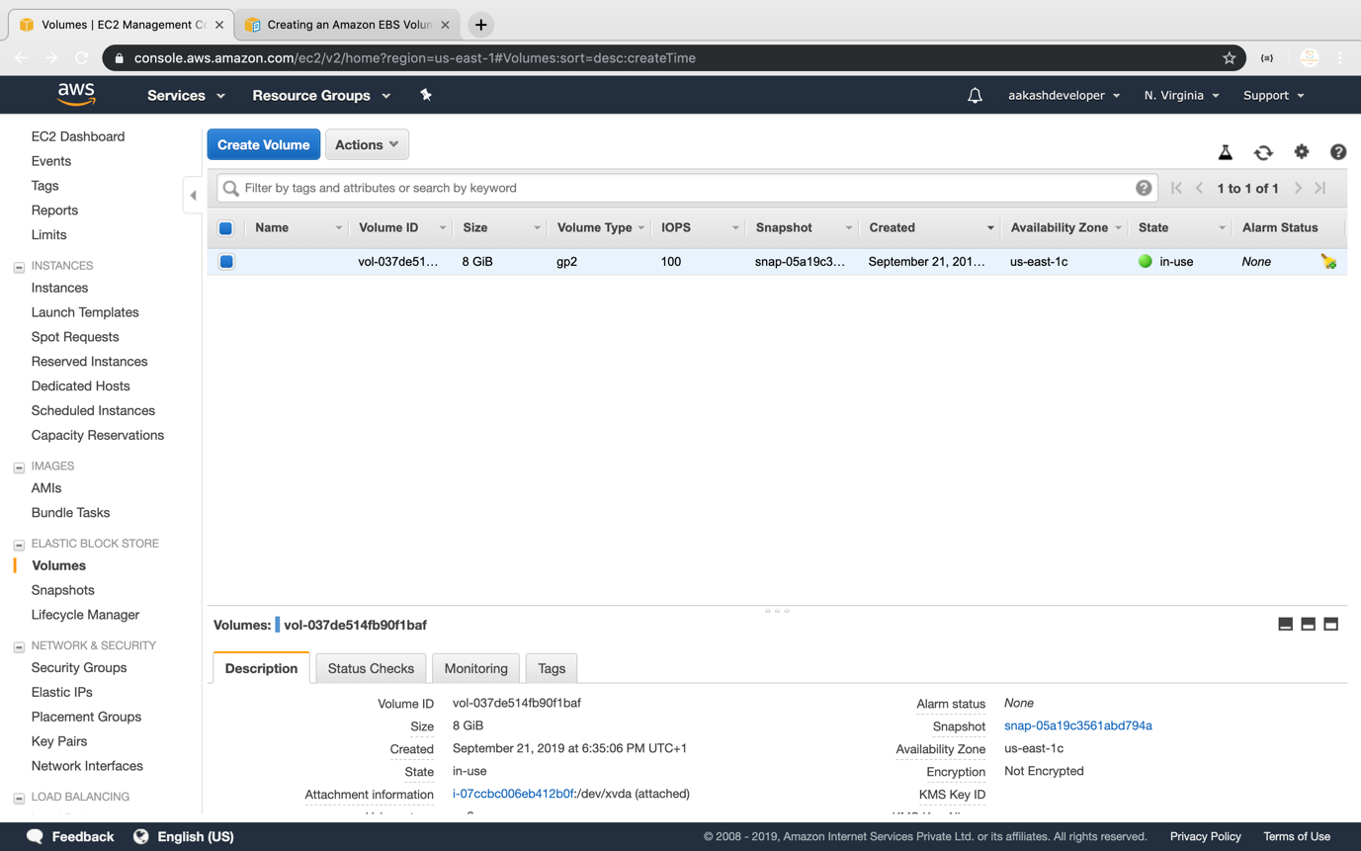

Selecting the volume type according to the project requirement

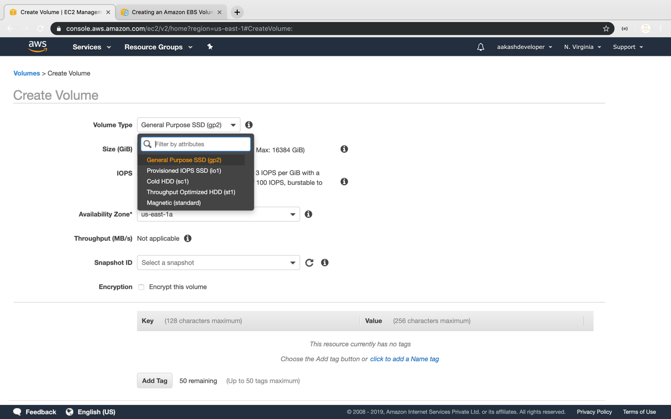

Creating a new volume by specifying the size and defining the zone

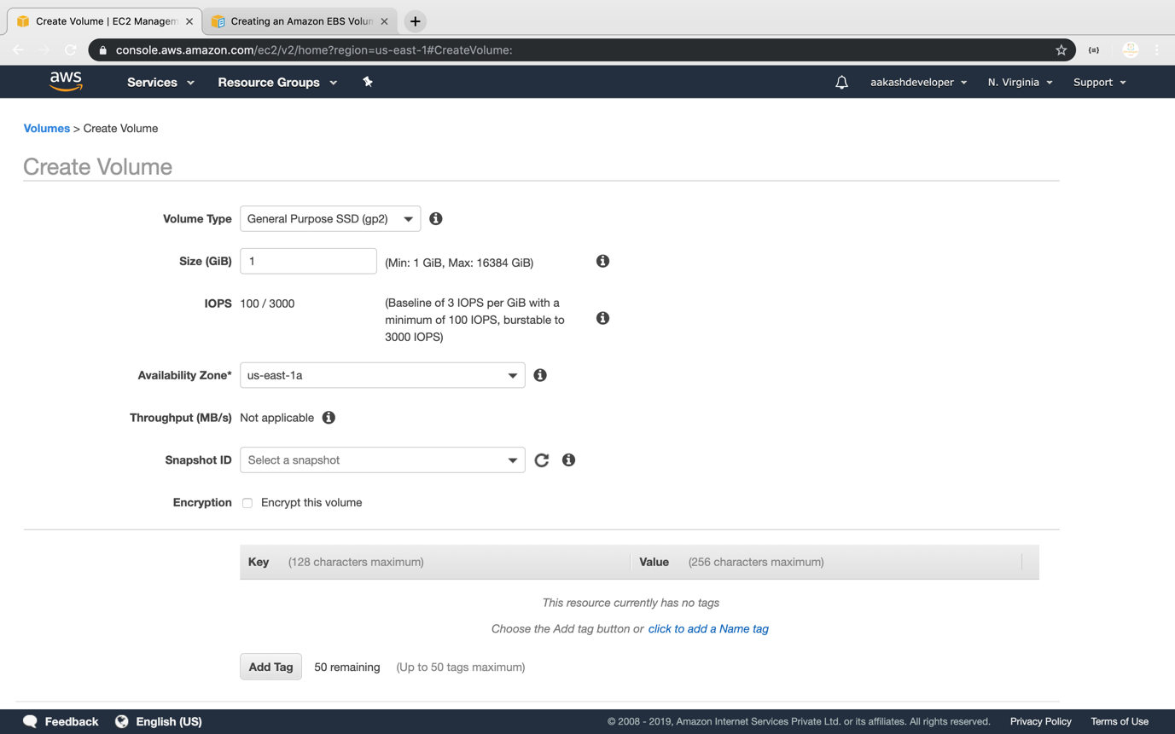

Verifying the new volume created on the volume console and its availability

